Live, Give, Grow, Go (64) Help One Child

Sharing Our Time Today with Danielle Pickard
Help One Child

Our Story About Kai through FaithBridge in Atlanta

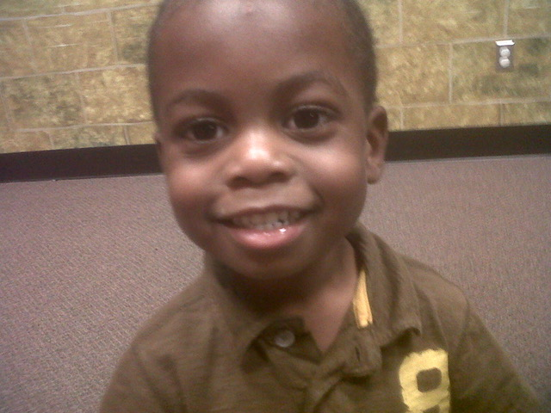

October 16, 2010

James 1:27
Pure and genuine religion in the sight of God the Father means caring for orphans and widows in their distress and refusing to let the world corrupt you.

- The center of God’s Work

- Bigger than just orphans and widows

  - Other-Focused

“Life's most persistent and urgent question is, 'What are you doing for others?” – MLK Jr.

1 John 3:17-19
¹⁷ If someone has enough money to live well and sees a brother or sister in need but shows no compassion—how can God’s love be in that person?
¹⁸ Dear children, let’s not merely say that we love each other; let us show the truth by our actions. ¹⁹ Our actions will show that we belong to the truth, so we will be confident when we stand before God.

Isaiah 58:10-12
Feed the hungry,
and help those in trouble.
Then your light will shine out from the darkness,
and the darkness around you will be as bright as noon.
¹¹ The Lord will guide you continually,
giving you water when you are dry
and restoring your strength.
You will be like a well-watered garden,
like an ever-flowing spring.
¹² Some of you will rebuild the deserted ruins of your cities.
Then you will be known as a rebuilder of walls
and a restorer of homes.

- “Rebuild the deserted ruins” -- emptiness and hollow existence…
- “Rebuilder of walls” -- brokenness
- “Restorer of homes” – Life Together family

Sign Up Today To Find Out More
Help One Child
CarePortal Training
August 12th
11:45-1:00 p.m.
Room 203

